**DAILY ONLINE ACTIVITIES SUMMARY**

|  |  |  |  |  |  |  |  |  |
| --- | --- | --- | --- | --- | --- | --- | --- | --- |
| **Date:** | **10th june,2020** | | | | | **Name:** | **Prathusha K A** | |
| **Sem & Sec** | **4th sem &b section** | | | | | **USN:** | **4AL18CS061** | |
| **Online Test Summary** | | | | | | | | |
| **Subject** | | **Object oriented concepts** | | | | | | |
| **Max. Marks** | | **30** | | **Score** | | | **24** | |
| **Certification Course Summary** | | | | | | | | |
| **Course** | **Cloud foundations.** | | | | | | | |
| **Certificate Provider** | | | **greatlearning** | | **Duration** | | | **6 hours** |
| **Coding Challenges** | | | | | | | | |
| **Problem Statement: :** Java Program to find the longest repeating sequence in a string  string: acbdfghybdf | | | | | | | | |
| **Status: done** | | | | | | | | |
| **Uploaded the report in Github** | | | | | **yes** | | | |
| **If yes Repository name** | | | | | **https://github.com/prathu47/lockdown-coding** | | | |
| **Uploaded the report in slack** | | | | | **yes** | | | |

Online Test Details: (Attach the snapshot and briefly write the report for the same)

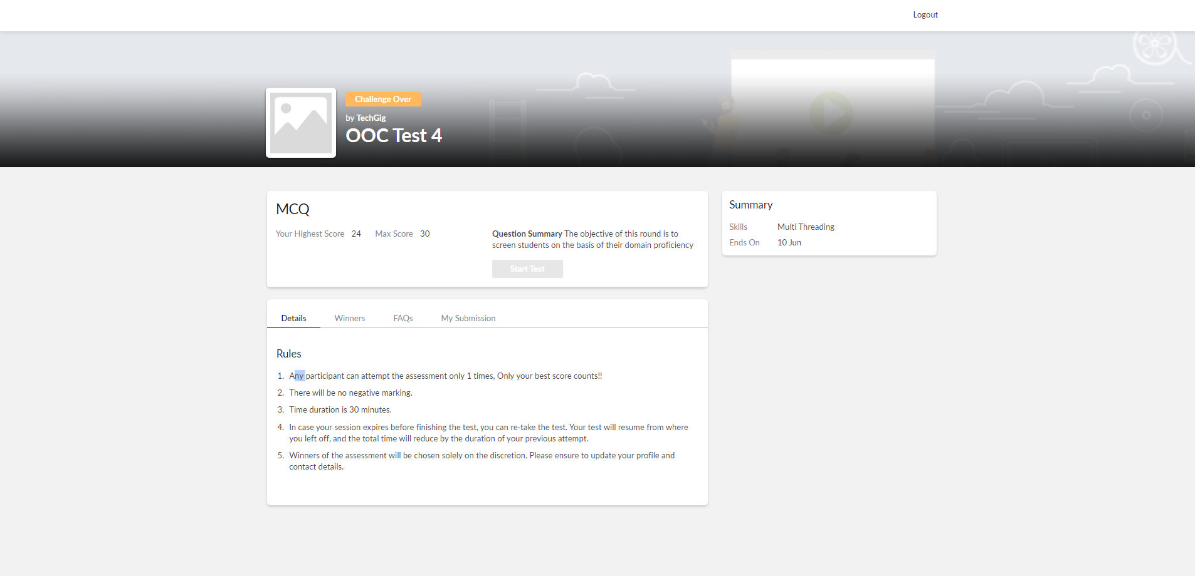

Object oriented concepts internals was conducted today. A total of 15 questions which is of mcq. Started at 9:15 AM and ended at 09:45AM each carries two marks.

The above snapshot is the result sheet which was sent to us by the Techgig team.

Certification Course Details: (Attach the snapshot and briefly write the report for the same)

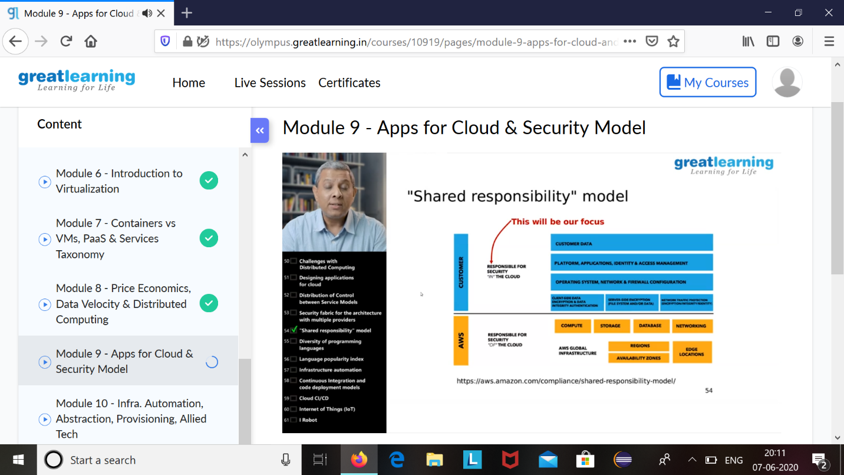

The course I have chosen during the lockdown period is Could foundations. Since previously I had interest in could computing I had choosen this course . Since cloud computing is gaining a lot of interest in software platform I have preferred to choose this course.

Coding Challenges Details: (Attach the snapshot and briefly write the report for the same)

Java Program to find the longest repeating sequence in a string

string: acbdfghybdf

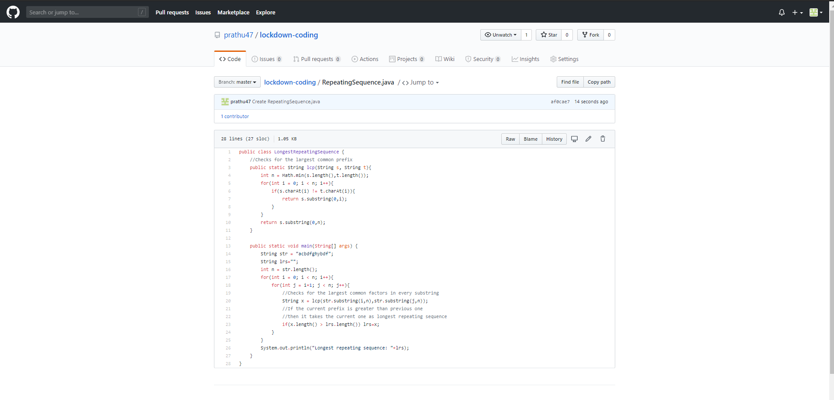

Code:The above snapshot is the code which I have uploaded in my github repository